TERMINAL CODE 1:

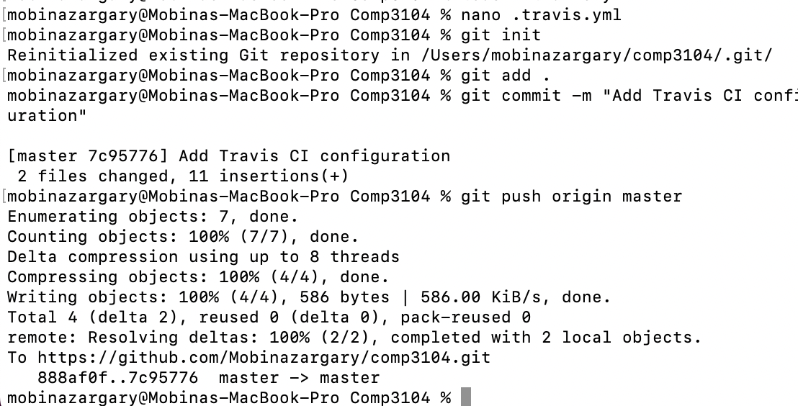

GITHUB TOKEN IN TRAVIS CI:

BUILD LOGS:

TRAVIS CI RUNNING:

GITHUB LINK: https://github.com/Mobinazargary/comp3104.git

